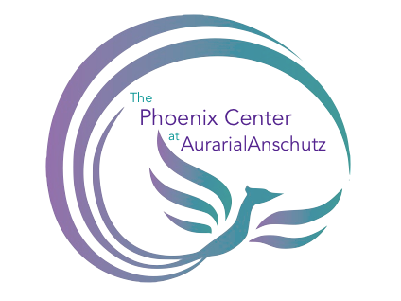

Working with Adult Men Policy

Purpose

Research has demonstrated that interpersonal violence impacts persons of all gender identities and expressions, including persons who identify or express themselves as masculine. The Phoenix Center at Auraria|Anschutz is committed to serving survivors of interpersonal violence without prejudice regarding actual or perceived sex, sexual orientation, gender identity, or gender expression. The purpose of this Policy is to ensure that Phoenix Center at Auraria|Anschutz provides equal access to all information and services to survivors and will take all reasonable steps within its control to meet the diverse needs of survivors regardless of actual or perceived sex, sexual orientation, gender identity, or gender expression including but not limited to people who identify and/or express themselves as masculine.

Further information regarding the PCA’s scope of service is available on our website and in our informational brochures.

Policy

Phoenix Center at Auraria|Anschutz is committed to this policy as the appropriate response to meeting survivors’ needs and will conform to federal requirements as listed in the section titled “DVP Guidance to Conform with Federal Requirements.”

Best Practices

Point of Service Contact | Examples of Working with Survivors of All Genders  Best Practices
Crisis Line | All crisis line advocates are trained to respond appropriately to callers’ needs regardless of actual or perceived sex, sexual orientation, gender identity, or gender expression including but not limited to persons who identify and/or express their gender identity as masculine. All advocacy screening tools and intake forms are designed to meet all survivor needs.
Community-Based Services | All community-based advocates must provide services (advocacy, counseling, support groups, etc.) to all survivors regardless of actual or perceived sex, sexual orientation, gender identity, or gender expression. All advocacy screening tools and intake forms are designed to meet all survivor needs including appropriate referrals.
Community Events | All community events are open to individuals regardless of perceived sex, sexual orientation, gender identity, or gender expression. Community events will inform the community that all services are available free of charge to all survivors of domestic violence regardless of actual or perceived sex, sexual orientation, gender identity, or gender expression.
Written Materials | All Phoenix Center at Auraria|Anschutz written materials including the Client Rights form, brochures, flyers, educational information, website content will use gender inclusive language such as pronouns that ensure the community is informed that services are available to individuals regardless of actual or perceived sex, sexual orientation, gender identity, or gender expression.  Phoenix Center at Auraria|Anschutz’s Client Bill of Rights explicitly references the existence and rights of male and LGBTQ+ survivors.  Vital documents (intake, confidentiality agreement, client rights, etc.) will be gender inclusive to establish access to information and services for all clients regardless of actual or perceived sex, sexual orientation, gender identity, or gender expression.

Implementation of Protocol

Training. Phoenix Center staff, student employees, interns and volunteers will be trained on policy and procedures upon employment. Yearly and as-needed refresher trainings will be offered for the duration of employment with The Phoenix Center.

Accessibility. Policy will be maintained in a publicly accessible digital database as well as in the policy manual located at the PCA front desk. All new staff, student employees, and volunteers will also receive a copy of the policy.

Review and update. Policy will be reviewed on an annual basis during the third calendar quarter and will be updated as needed.

Concerns. Employees and volunteers should work directly with supervisors with questions or concerns, or to report difficulties in accessing the indicated resources.

Resources

The Blue Bench – Breaking the Silence Support Group
https://thebluebench.org/get-help/for-myself/groups-and-workshop-descriptions.html

Support for Male Survivors
https://1in6.org

